
Name___________________________

Maths Specialist - Investigation

Matrix Transformations

Investigation Part 1: Preparation activity

A point in the $x$-$y$ plane can be expressed as a 2 $×$ 1 matrix: for example, the point (1, 2) can be written as$\left[\begin{matrix}1 \\ 2\end{matrix}\right]$.

This point can then be transformed into another point by multiplication by a $2×2$matrix.

$\left[\begin{matrix}1 & 0 \\ 0 & -1\end{matrix}\right]×\left[\begin{matrix}1 \\ 2\end{matrix}\right]=\left[\begin{matrix}1 \\ -2\end{matrix}\right]$

Transformation matrix $×$ point = Transformed point

[NB: The transformation matrix is pre-multiplied by the point.]

Questions 1

Use the shape joined by the co-ordinates 0(0,0), A(1,0), B(1,2) and C(0,2), to investigate the effect of 2x2 transformation matrices of these types:

Matrix | Calculation | Diagram | Effect – Shape, position, size
$$\left[\begin{matrix}1 & 0 \\ 0 & 1\end{matrix}\right]$$ |  | 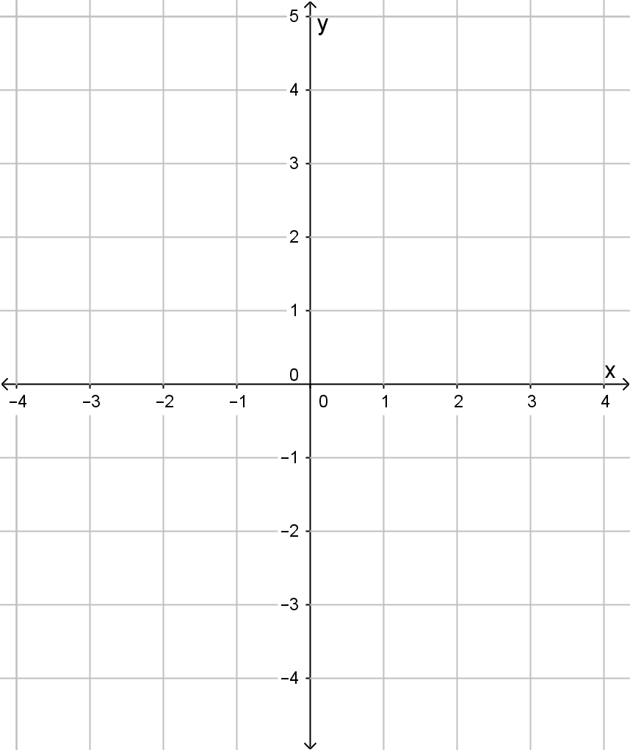
$$\left[\begin{matrix}1 & 0 \\ 0 & -1\end{matrix}\right]$$ |  | 
$$\left[\begin{matrix}-1 & 0 \\ 0 & 1\end{matrix}\right]$$ |  | 
$$\left[\begin{matrix}0 & 1 \\ 1 & 0\end{matrix}\right]$$ |  | 
$$\left[\begin{matrix}0 & -1 \\ 1 & 0\end{matrix}\right]$$ |  | 
$$\left[\begin{matrix}2 & 0 \\ 0 & 1\end{matrix}\right]$$ |  | 
$$\left[\begin{matrix}1 & 0 \\ 0 & 3\end{matrix}\right]$$ |  | 
$$\left[\begin{matrix}3 & 0 \\ 0 & 3\end{matrix}\right]$$ |  | 
$$\left[\begin{matrix}1 & 2 \\ 0 & 1\end{matrix}\right]$$ |  | 

Question 2
Investigate the effect of a transformation by the following matrices, where k is a constant.

$$\left[\begin{matrix}k & 0 \\ 0 & 1\end{matrix}\right]$$

$$\left[\begin{matrix}1 & 0 \\ 0 & k\end{matrix}\right]$$

$$\left[\begin{matrix}k & 0 \\ 0 & k\end{matrix}\right]$$

$$\left[\begin{matrix}1 & k \\ 0 & 1\end{matrix}\right]$$

Question 3
- Find the area of rectangle $OABC$

For each the matrices in question 1,
- find the absolute value of the determinant of the matrix.

- Find the area of $O^{'}A^{'}B^{'}C^{'}$ the image of $OABC$ under the transformation.

- Find the value of $\frac{Area O^{'}A^{'}B^{'}C^{'}}{Area OABC}$
Matrix | Determinant | $$Area O^{'}A^{'}B^{'}C^{'}$$ | $$\frac{Area O^{'}A^{'}B^{'}C^{'}}{Area OABC}$$

- What do you notice?

By using the same transformation matrices above investigate the effect on a different shape.
Can you predict the effect the transformation matrices will have?
Can you predict the area of the image after it has been transformed the matrix?

